Fa23-bse-136 section c

Shayaan shahid

ict lab task python

Qno1

total_sum=0

for i in range(10):

value=int(input("enter the num:\n"))

total_sum += value

print("total sum ",total_sum)

average = total_sum/10

print("average :",average)

Qno2

for i in range(,101,+1):

print(i)

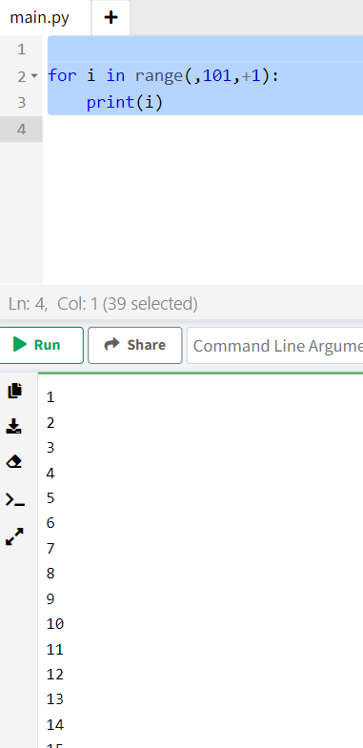

Qno3

for i in range(101,0,-1):

print(i)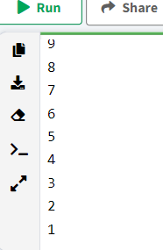

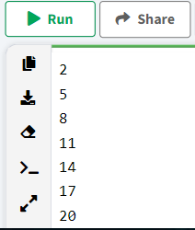

Qno4

for i in range(20,2,-2):

print(i)

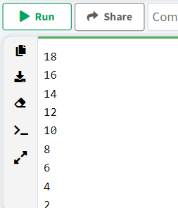

Qno5

for i in range(2,23,+3):

Qno6

print(i)

for i in range(99,-11,-11):

print(i)

Qno7

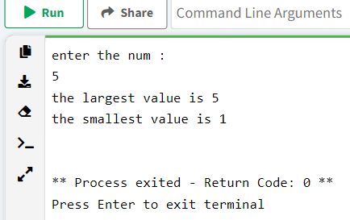largest=-99999

smallest=9999999

for i in range(5):

value=int(input("enter the num :"))

if value > largest:

largest=value

if value < smallest:

smallest=value

print("the largest value is",largest )

print("the smallest value is",smallest)

Qno8

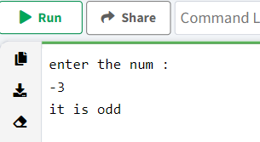value=int(input("enter the num :"))

mod=value%2

if mod==0:

print("it is even")

else:

print("it is odd")

Qno9

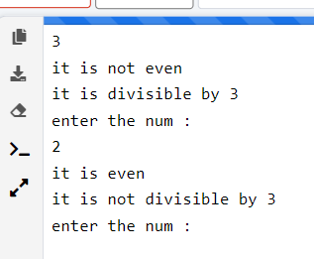for i in range(10):

value=int(input("enter the num :"))

mod=value%2

div=value%3

if mod==0:

print("it is even")

else:

print("it is not even")

if div==0:

print("it is divisible by 3")

else:

print("it is not divisible by 3")

Qno10

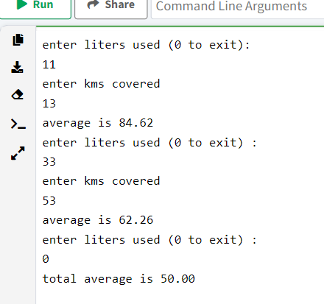

total_petrol=0

total_distance=0

liters=float(input("enter liters used (0 to exit):"))

while liters>0:

if liters==0:

break

if liters>0:

kms=float(input("enter kms covered"))

average=100*liters/kms

print("average is",format(average,".2f"))

liters=float(input("enter liters used (0 to exit) :"))

total_petrol=total_petrol+liters

total_distance=total_distance+kms

total_average=0

total_average=100*total_petrol/total_distance

print("total average is",format(total_average,".2f"))

Qno11

sum=0

x=2

while x>=2 and x<=30:

mod=x%2

if mod==0:

sum=sum+x

x+=1

print("total sum of nums :",sum)

Qno12

product=1

x=3

while x>=3 and x<=19:

mod=x%2

if mod!=0:

product=product*x

x+=1

print("total product of nums :",product)

Qno13

num=int(input("enter a four digit number"))

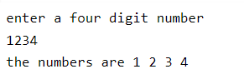digit1=int(num/1000)

x=num/100

digit2=int(x%10)

y=num/10

digit3=int(y%10)

digit4=int(num%10)

print(f"the numbers are {digit1} {digit2} {digit3} {digit4} ")

Qno14

account=int(input("Enter account number (-1 to end)"))

while True:

if account==-1:

break

else:

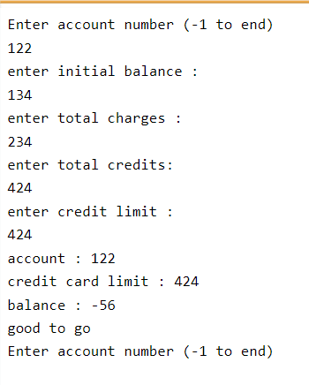 initial=int(input("enter initial balance :"))

total_charge=int(input("enter total charges :"))

credits=int(input("enter total credits: "))

limit=int(input("enter credit limit :"))

current=initial+total_charge-credits

print("account :",account)

print("credit card limit :",limit)

print("balance :",current)

if current>limit:

print("limit exceeded")

else:

print("good to go")

account=int(input("Enter account number (-1 to end)"))

Qno15

basic_salary=200

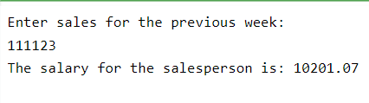rate=0.09

sales=float(input("Enter sales for the previous week: "))

commission =sales*rate

total_salary=basic_salary+commission

print("The salary for the salesperson is:",format(total_salary,".2f"))